Applying Polymer Science to Extrusion and Drying of Pet Foods
By Brian Plattner, Robert Sunderland and Keith Erdley

Introduction
Polymer science, the study the glass and melt transitions of polymers, has been developed and used by the synthetic polymer industry for many years. In recent years the principles of polymer science have been applied to the pet food extrusion process to better understand and predict processing effects. Strahm (1998) gives a more complete review of the concepts of glass and melt transitions and their possible applications to extrusion processing.

There are several instruments that can be used to measure the physical changes associated with the glass transition and melt transition in biopolymers such as starch and protein during thermal processing. Some instruments are not configured to measure a sample’s transition temperatures under typical extrusion conditions. In addition, these instruments are often too sensitive to measure the “controlling” T_{s} and T_{f} for a complex blend of raw materials that often include starch, protein, fat, fiber, and ash (Strahm and Plattner 2001). The controlling T_{s} is the temperature at which a sufficient amount of a sample is softened to allow for particle compaction (T_{s}) or melted to allow for flow (T_{f}) through a small orifice.
Figure 1: Schematic Diagram of the PTA.
US Patent # 6,534,005

One tool that can measure these transitions is the Phase Transition Analyzer® or PTA (Figure 1). While the PTA does not provide all the answers to questions about how pet foods change under thermal processing, it does provide many unique and potentially useful insights for the pet food extrusion and drying process.

Measuring Transition Temperatures
To measure the T_{s} of a pet food sample, a blank die (no orifice) is inserted into the PTA, a two gram sample is loaded, and the pressure is preset to 120 bar and maintained for ten seconds. This initial compaction allows the sample to be formed into a solid pellet, thus reducing the bridging effects that can occur with high moisture samples (above 20 percent wet basis). The pressure is then reduced to 80 bar and the sample is typically heated at a rate of increasing temperature, usually ten degrees Celsius per minute. As the sample is heated at constant pressure, it begins to compact (Figure 2). This initial compaction occurs over a temperature range. The midpoint point of the temperature range is assigned the value of T_{s}. Once the initial compaction has ended, the temperature is held constant and the blank die insert is replaced with a second die (2.0 mm orifice). The sample is recompressed and the temperature is again raised at an operator-determined rate. As the sample heating continues, the sample begins to flow through the orifice. The temperature at which the flow begins is called T_{f}.
Figure 2: Sample Compaction and Flow During Testing in the PTA.

Figure 3 shows an example of data generated using the PTA. The displacement is tracked as the sample is heated. As the particles begin to compact the T_{s} transition is indicated by a change in sample displacement. The T_{s}, as determined by the PTA, is reported as the average of T_{s} (onset) and T_{s} (endpoint). T_{f}, which is detected by the displacement transducer, is indicated by the flow of the sample through the die orifice.
Figure 3: Typical PTA data.

Applying Polymer Science to Pet Food Processing
One of the more difficult pet food products to extrude and dry is a diet which contains a high level of fresh meat. The addition of meat adds significant moisture to the process creating cooking and hydration issues in the preconditioner and extruder. Recipes with high levels of fresh meat are subject to significant deformation during cutting and conveying because the extruded kibbles are very soft. Fresh meat contains significant undenatured and functional protein which holds onto the moisture and requires long retention times in the dryer.
Figure 4: State Diagram for Extrusion Process
Applying the principles of polymer science creates an understanding of the processing issues occurring during the extrusion and drying of diets containing high levels of fresh meat. As demonstrated by Plattner et al. (2001) a state diagram can be developed which relates the extrusion process to the material’s properties (Figure 4).

When constructing a state diagram, the process technologist must first plot the T_{s} and T_{f} curves. Plotting these curves allows one to determine where the pet food product will behave as a glass, rubber, or liquid. When a material is below its glass transition temperature (T_{s}) it has a hard, brittle structure. When force is applied to it, the kibble will break or shatter. A product that exists in its rubbery form, between the T_{s} and T_{f} curves will a have soft pliable texture. When force is applied, the material can be deformed or reshaped; however, it still has enough rigidity to hold its own weight. Above its flow temperature a product will resemble a liquid. At temperature and moisture combinations close to the T_{f} curve the material will act as a viscous liquid. As the material moves further into the melted region the viscosity thins dramatically. Product must be in a melted state in order to be forced through an extruder die. Kibbles in this region exhibit soft dough-like textures that will compress and deform under their own weight. Deformation can also occur as cutting blades throw the product into the surrounding knife hood. The force of hitting the wall of the hood will cause the soft kibbles to flatten and adhere to each other creating clumps. As the kibbles enter the dryer and are stacked on top of each other, large clumps can be formed as shown in Figure 5.
Figure 5: Formed Clumps
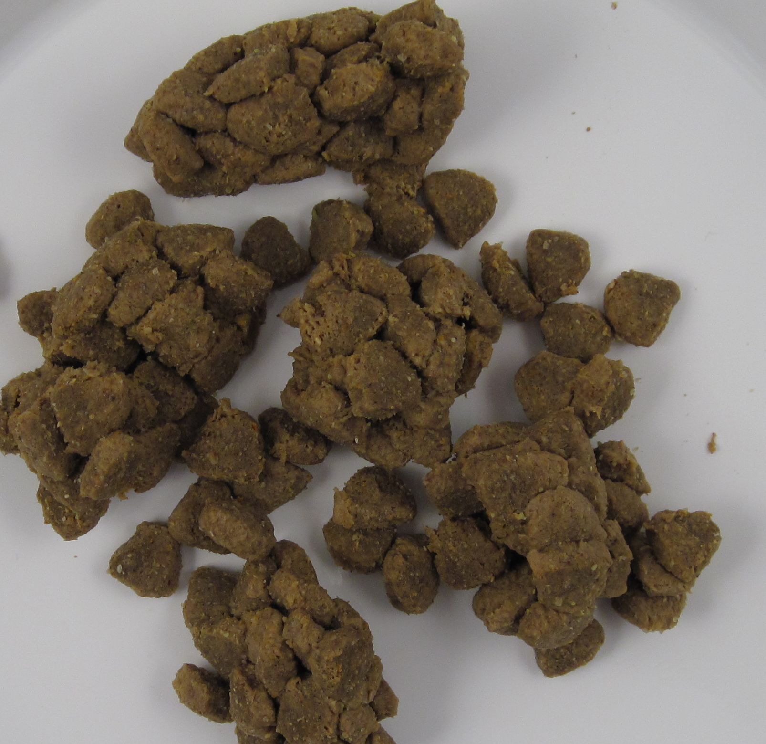
Once the transition curves have been determined, a mass and energy evaluation is performed to determine the product’s conditions (temperature and moisture) at various points in the process (Riaz 2000). These process points can then be plotted as shown in (Figure 4).
Figure 6: Post Extrusion Processing of High Meat Pet Food

The raw material enters the extrusion process at low moisture and temperature. It is then metered into the preconditioner and mixed with chilled, emulsified fresh meat and heated with direct steam injection. The moisture and temperature addition result in the material moving from a glassy state thru the rubbery region and entering the melted region just before exiting from the preconditioner. As the material enters the extruder, additional moisture and energy is added in the form of direct steam injection and mechanical energy input from the extruder main drive motor. This additional energy drives the material further into the melted region creating a melt that has relatively low viscosity. As the product leaves the extruder, some of the moisture flashes off as the product goes through evaporative cooling. Figure 4 shows that the material is still well above its melt transition temperature even after this cooling step. Thus, the product could be susceptible to deformation.
Figure 7: Drying Curve for High Meat Pet Food

To minimize and avoid these process issues it is helpful for the process technologist to understand how to apply polymer science and a state diagram to the pet food process. To keep the product from significant deformation the transition from the melted region to the rubbery region must be controlled (Figure 6). Once the product is below the melt transition curve it will still be deformable; however, it will have enough structural integrity to support the combined weights of other kibbles thus reducing the potential for deformation and clumping.
Figure 8: Segmented Drying Curve
Drying the kibbles will move them below the melt transition line. The data in Figure 6 indicates that the product moisture needs to be lowered to around 15 percent at temperatures below 80ºC to reach the rubbery region.

One way of lowering the moisture content is to use a predryer with a shallow bed depth. This would allow the moisture to be reduced while maintaining a shallow enough bed to keep the product from clumping and deforming due to the surrounding weight of the kibbles. A drying curve for the product must be developed to properly size a predryer. A sample of this product was collected just off of the extruder and a drying curve was developed by measuring the moisture loss from the product over a period of nearly an hour (Figure 7).
Figure 9: State Diagram for Extrusion & Drying of Pet Food

The drying curve indicates that it takes approximately 30 minutes for the average product moisture to drop below the targeted 15 percent leve. If a shallow bed depth is maintained throughout the predrying process to prevent clumping, the predryer becomes quite large and therefore expensive.

When developing a drying curve for a given product, the moisture content is usually depicted as the average moisture of the kibble. However, at any particular location along the drying curve, the moisture at the surface of the kibble will be less than the average, while the center of the kibble will have a higher moisture level due to the slow migration from the center to the outside. Figure 8 shows a segmented drying curve. Each curve shown on this chart depicts a different layer or segment of the kibble. The bottom-most curve is the outside surface while the top curve reflects the center of the kibble.
Figure 10: Properly Dried and Cooled Kibbles

These curves show that the surface of the kibble reaches 15 percent moisture after about nine minutes of drying. At this point the surface of the kibbles has transitioned from the melted state to a rubbery state. If we look back to Figure 7 we can see that the average moisture content of the kibble is still near 28 percent which tells us that the bulk of each kibble is still well above its melt transition point. But since the surface properties are now in the rubbery region, the kibbles are strong enough to hold the stacked weight of the surrounding kibbles without deformation. Since the kibbles can now be stacked the size, footprint, and overall capital investment of the predryer is reduced.

A more accurate state diagram can be constructed using the extrusion conditions shown in Figure 4 with the drying curve of the product surface shown in Figure 8. This combined state diagram is depicted in Figure 9. As shown in this state diagram, the easily deformable product is carefully dried in a predryer until the surface has reached the rubbery region. Then a more traditional pet food drying step reduces the moisture to a shelf-stable level and the product is cooled prior to packaging. This allows the final kibbles to free flowing with limited deformation (Figure 10).

Conclusion
The proper use of polymer science can allow the process technologist to not only understand the basic biopolymer properties, but also allows for a practical application to pet food processing. When applied properly, these principles can assist in designing and developing the most appropriate extrusion and drying process for pet foods.

Strahm, B. 1998. Fundamentals of Polymer Science as an Applied Extrusion Tool. Cereal Foods World. 43(8): 621-625.
Plattner, B., J. Herbster, and B. Strahm. 2001. Phase Transition Analysis: Predictive Control of Extrusion. Pet Food Industry. Volume 43(10):15-16. Watt Publishing, Inc. Mt. Morris, Illinois.
Riaz, M. N. ed. 2000. Appendix in Extruders in Food Applications. Technomic Publishing Co.,Inc. Lancaster, PA, 17604.

