Kemin Palatant News

Petfood manufacturers already enjoy competitive performance with the range of PALASURANCE® products, and Kemin’s commitment to petfood palatability continues to grow.

PALASURANCE R&D benefits from Kemin’s expertise in complimentary areas of antioxidants and antimicrobials. Years of ongoing vendor monitoring experience stabilizing oxidation and quality in raw materials puts Kemin at an advantage for building consistent palatant performance, starting with the ingredients.

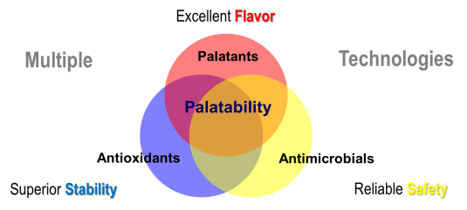

Kemin also draws on a broad range of technology platforms from diverse businesses, such as fermentation for the production of enzymes for agricultural applications. In addition, Kemin welcomes Dr. Gordy Hering as the Director of R&D for palatants who brings experience in enzymatic hydrolysis and reaction flavors, key elements of petfood palatant performance. Kemin’s understanding of enzyme function in palatants at the molecular level is one of the factors contributing to continuous improvement for the PALASURANCE product range.

