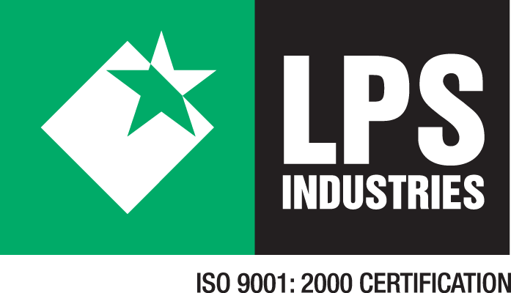

LPS Industries LLC
10 Caesar Place
Moonachie NJ 07074

FOR IMMEDIATE RELEASE CONTACT: Charles Ardman
June 8, 2010 201-438-3515 x-311

LPS Industries Demonstrates Commitment to the Environment with Record
Solar Panel Installation
MOONACHIE, NJ., June 8, 2010 –LPS Industries, a diversified manufacturer and leader in the flexible packaging industry, today announced it has completed the largest Solyndra solar panel rooftop installation in the United States, a 704.34kW system. The installation will provide 25% of the power for the 165,000 sq. ft. manufacturing facility and is part of a larger commitment to reduce energy consumption and produce packaging products in the most sustainable manner.
“We have a reputation for our innovation in packaging products and we were looking for equally innovative ways to reduce our energy use and costs,” said Madeleine Robinson, CEO, LPS Industries. “We wanted a solar integrator that could deliver the best technology and was sensitive to our facility’s limitations. We chose Solis Partners who introduced us to the unique Solyndra product. With its building friendly design including superior wind performance, low weight along with strong energy production, Solyndra clearly emerged as the best solution.”
The LPS installation consists of 3,870 Solyndra solar panels, producing over 825,000 kWh of electricity and eliminating more than 1,100,000 pounds of CO2 emissions annually – enough energy to remove 93 cars from the road or power more than 100 residential homes per year. Solis Partners designed, engineered and installed the system in combination with a new white ‘cool’ roof system. Solis worked with Allied Building Products on procurement, financing, logistics and staged rooftop delivery to complete the entire project in just a few months.
“LPS customers, whether in medical, food, pet food, agriculture or shipping, are increasingly looking for suppliers who conduct their businesses in a highly sustainable manner,” said Jamie Hahn of Solis Partners. “LPS came to us with a desire to use available incentives to maximize the size of the solar array they could purchase and the amount of power it will produce. They also preferred a product made in the United States. The Solyndra product was a perfect fit.”
With Solis’s strong understanding of local and federal incentives, they worked with LPS, Allied and PSE&G, the local utility, to ensure the lowest turn-key system cost for LPS. The project was partially financed by the innovative PSE&G Solar Loan program which will be repaid by Solar Renewable Energy Certificates (SRECs).
“We are pleased to help LPS Industries join the growing list of companies in New Jersey committed to carbon-free electricity production,” said Al Matos, vice president – renewables and energy solutions for PSE&G. “By taking advantage of financing through our Solar Loan Program, LPS Industries is demonstrating that renewable energy sources such as solar power make sense for the environment and for a company’s bottom line.”
# # #

About LPS Industries
LPS Industries, headquartered in Moonachie, New Jersey is a diversified manufacturer and leader in the flexible packaging industry providing packaging solutions to many market segments such as medical, food, transportation, electronics and agriculture. Woman owned and operated, LPS Industries is an ISO 9001:2000 Certified company and offers three separate products groups: flexible packaging, coated products and general packaging materials. The company’s website is www.lpsind.com.
About Solis Partners

Solis Partners LLC is a leading developer and integrator of solar power systems to commercial, industrial and utility clients. Solis Partners designs, engineers and constructs leading-edge, optimized solar power systems enabling customers to meet their long-term energy needs while reducing operating costs and addressing their carbon liabilities. Solis is a comprehensive partner, offering the complete solution for both solar and roofing. Solis Partners is headquartered in Manasquan, New Jersey. For more information, please call (732) 800-0052, or visit www.solisllc.com.

About Solyndra
Headquartered in Fremont, Calif., Solyndra designs and manufactures photovoltaic systems, comprised of panels and mounts, for the commercial rooftop market. Using proprietary cylindrical modules and thin film technology, Solyndra’s light weight, non-penetrating systems are designed to provide simple and easy installations and the lowest cost of electricity for typical low slope commercial rooftops.

About Allied Building Products

Allied Building Products Corp. distributes building products to specialty contractors from over 180 locations throughout the U.S. Allied is a division of Oldcastle, Inc., the North American holding company for CRH plc (NYSE: CRH). Allied’s solar division supplies Solyndra panels, inverters, and other solar products to qualified contractors. For more information, please call 1-(877) 870-7887.

For more information, please contact

LPS Industries
Charles Ardman at cardman@lpsind.com or 201-438-3515, ext 311

Solyndra
Dave Miller at david.miller@solyndra.com or (510) 440-2979

