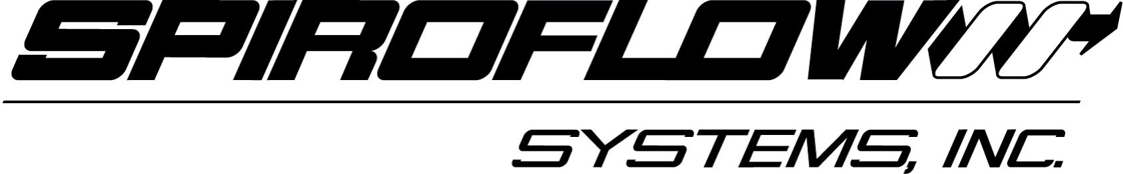 NEWS RELEASE

NEW FLEXIBLE SCREW CONVEYOR FROM SPIROFLOW SYSTEMS INCREASES THROUGHPUT AND REDUCES COST

Contact: Dick Stark FOR IMMEDIATE RELEASE
(803) 802-7141 December, 2009

CHARLOTTE, N.C.--- A Flexible Screw Conveyor (FSC) from Spiroflow Systems, Inc., moves dry bulk solids and ingredients at higher throughputs than ever before. Thanks to a new and simplified direct electric motor-driven spiral screw, the conveyor rotates at faster speeds than previous models. Spiroflow is a pioneer of the FSC concept. With fewer parts to wear, the new ’Spiroflow’ FSC is lower in cost since many unnecessary components have been eliminated and has a more sanitary modular design for greater flexibility in adapting to new applications.
Low Maintenance
Maintenance is reduced since the only moving part is the spiral screw that rotates material within a sealed tube and moves it along by its revolutionary homogenizing conveying action.
Increased Capacity/Lower Costs
Faster rotation of the spiral screw increases capacity allowing the use of a smaller conveyor to handle larger loads saving on floor space and reducing equipment investment cost
Improved Construction/Easy to Clean
With its sanitary design, the FSC meets the hygienic conveying needs
(more)
SPIROFLOW INTRODUCES NEW FSC CONVEYOR
ADD 1

demanded by the food, pharmaceutical and other industries. This is made
possible by Spiroflow’s upgraded spiral screws that are now available in ultra-high grade and heat-tempered stainless steel or heat-treated spring steel for longer life. With fewer parts than most companies’ gearbox driven models, the ‘Spiroflow’ FSC is easy to clean by simply reversing the motor and dry brushing or flushing with liquid. Optional interlocked, quick-release connectors permit rapid dismantling and reassembly, minimizing downtime.
Gentle Handling
Since the ‘Spiroflow’ FSC spiral screw is centralized in the conveying tube by material, little or no degradation occurs. Screw action continuously remixes the conveyor contents, eliminating the separation risk inherent in pneumatic conveyors and maintaining proper composition of particles with different size and density making the ‘Spiroflow’ FSC ideal for feeding pre-mixed ingredients to packaging and tableting machines.
Design Simplicity
Design simplicity eliminates the need for additional operating equipment such as gear reducers or bearings (in most applications), adding up to a system that’s sanitary in design, easy to clean, low in installation and maintenance costs and high in efficiency and performance. The conveying system is fully enclosed
and doesn’t use air as a conveying medium, making it dust free, reducing
(more)
SPIROFLOW INTRODUCES NEW FSC CONVEYOR
ADD 2

cleaning costs and increasing employee safety.
Modular Design
Modular design provides a greater range of uses and allows adapting the FSC to new applications for which the conveyor was not originally specified. The conveying systems can be configured to operate in any direction and elevation between horizontal and vertical. Multiple conveyors can also be linked. The flexible design allows installation around obstacles and through small openings in walls to maximize space.
Technical Data
Nine models of the new FSC are available, with throughputs from 10 to 88,000 pounds per hour (4 kilograms/hour to 40,000 kilograms/hour) depending on the material and the angle of operation. Units are also available for special heavy-duty applications involving highly abrasive materials such as metals, aggregates and glass cullet and for applications in explosive atmospheres that can be designed to comply with NEMA and/or ATEX applications.
Fully antistatic machines are also available eliminating any static build up in the conveying system.
Three types of spiral screws are available: a standard round screw that handles most applications, a flat screw for certain light or aerated products and a beveled screw for conveying difficult materials such as iron oxide or products that
(more)
SPIROFLOW INTRODUCES NEW FSC CONVEYOR
ADD 3

smear such as chocolate.
About Spiroflow Systems
Spiroflow is a worldwide supplier of a wide range of both standard and
custom powder handling equipment, specializing in Bulk Bag Dischargers and Fillers, Mechanical and Pneumatic Conveyors, a range of 50-pound Bag Packing and Unloading equipment and Flexible Storage Silos. The company offers a wide range of innovative designs and design options.
An in-house test facility offers a free on-site and on-line service to customers to analyze and demonstrate material flow properties under actual operating conditions. This, in turn, sets the parameters for selecting the most suitable handling method for your process and ensures equipment is installed properly. Any system tested in our test facility is guaranteed.
For more information on the all new design Flexible Screw Conveyor or Spiroflow’s complete line of powder handling equipment, visit www.spiroflowsystems.com, call 704-291-9595 or email info@spiroflowsystems.com.
###
Editor contact: Dick Stark or Kevin Nichols, Stark & Associates, Inc.
1171 Market St., Ste. 113, Fort Mill, SC 29708
PH: 803-802-7141 or email Dick.Stark@starklmc.com or Kevin.Nichols@Starklmc.com.

Caption #1

Typical ‘Spiroflow’ Flexible Screw Conveyor application. The Flexible Screw Conveyor (FSC) from Spiroflow Systems, Inc. moves dry bulk solids and ingredients at higher throughputs than ever before. Thanks to a new and simplified direct electric motor-driven spiral screw, the conveyor rotates at faster speeds than previous models. With fewer parts to wear, the new ‘Spiroflow’ FSC is lower in cost since many unnecessary components have been eliminated and has a more sanitary modular design for greater flexibility in adapting to new applications. The upgraded spiral screws are available in ultra-high grade heat-tempered stainless steel or heat-treated spring steel for longer life.

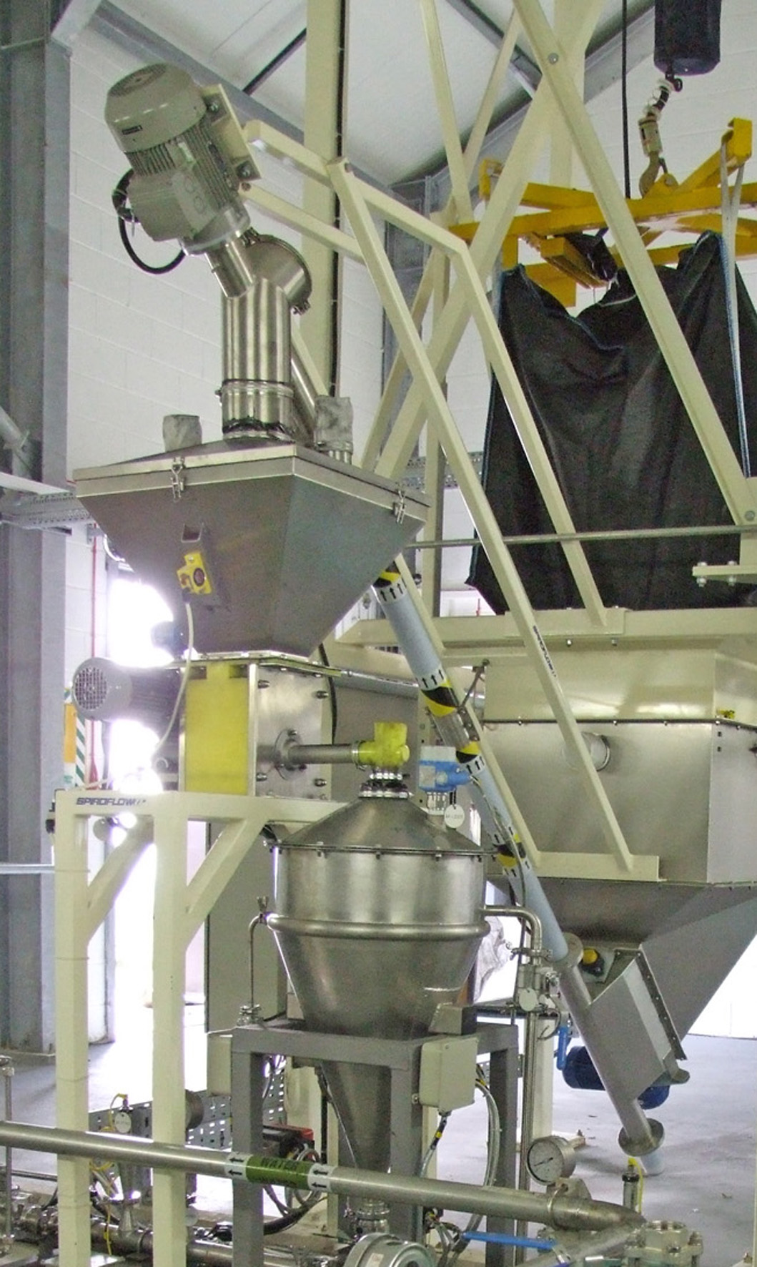
Caption #2

Nine models of the new Flexible Screw Conveyor (FSC) from Spiroflow Systems, Inc. are available introduced with throughputs of from 10 to 88,000 pounds/hour (4 kilograms/hour to 40,000 kilograms/hour) depending on the product and the angle of operation.

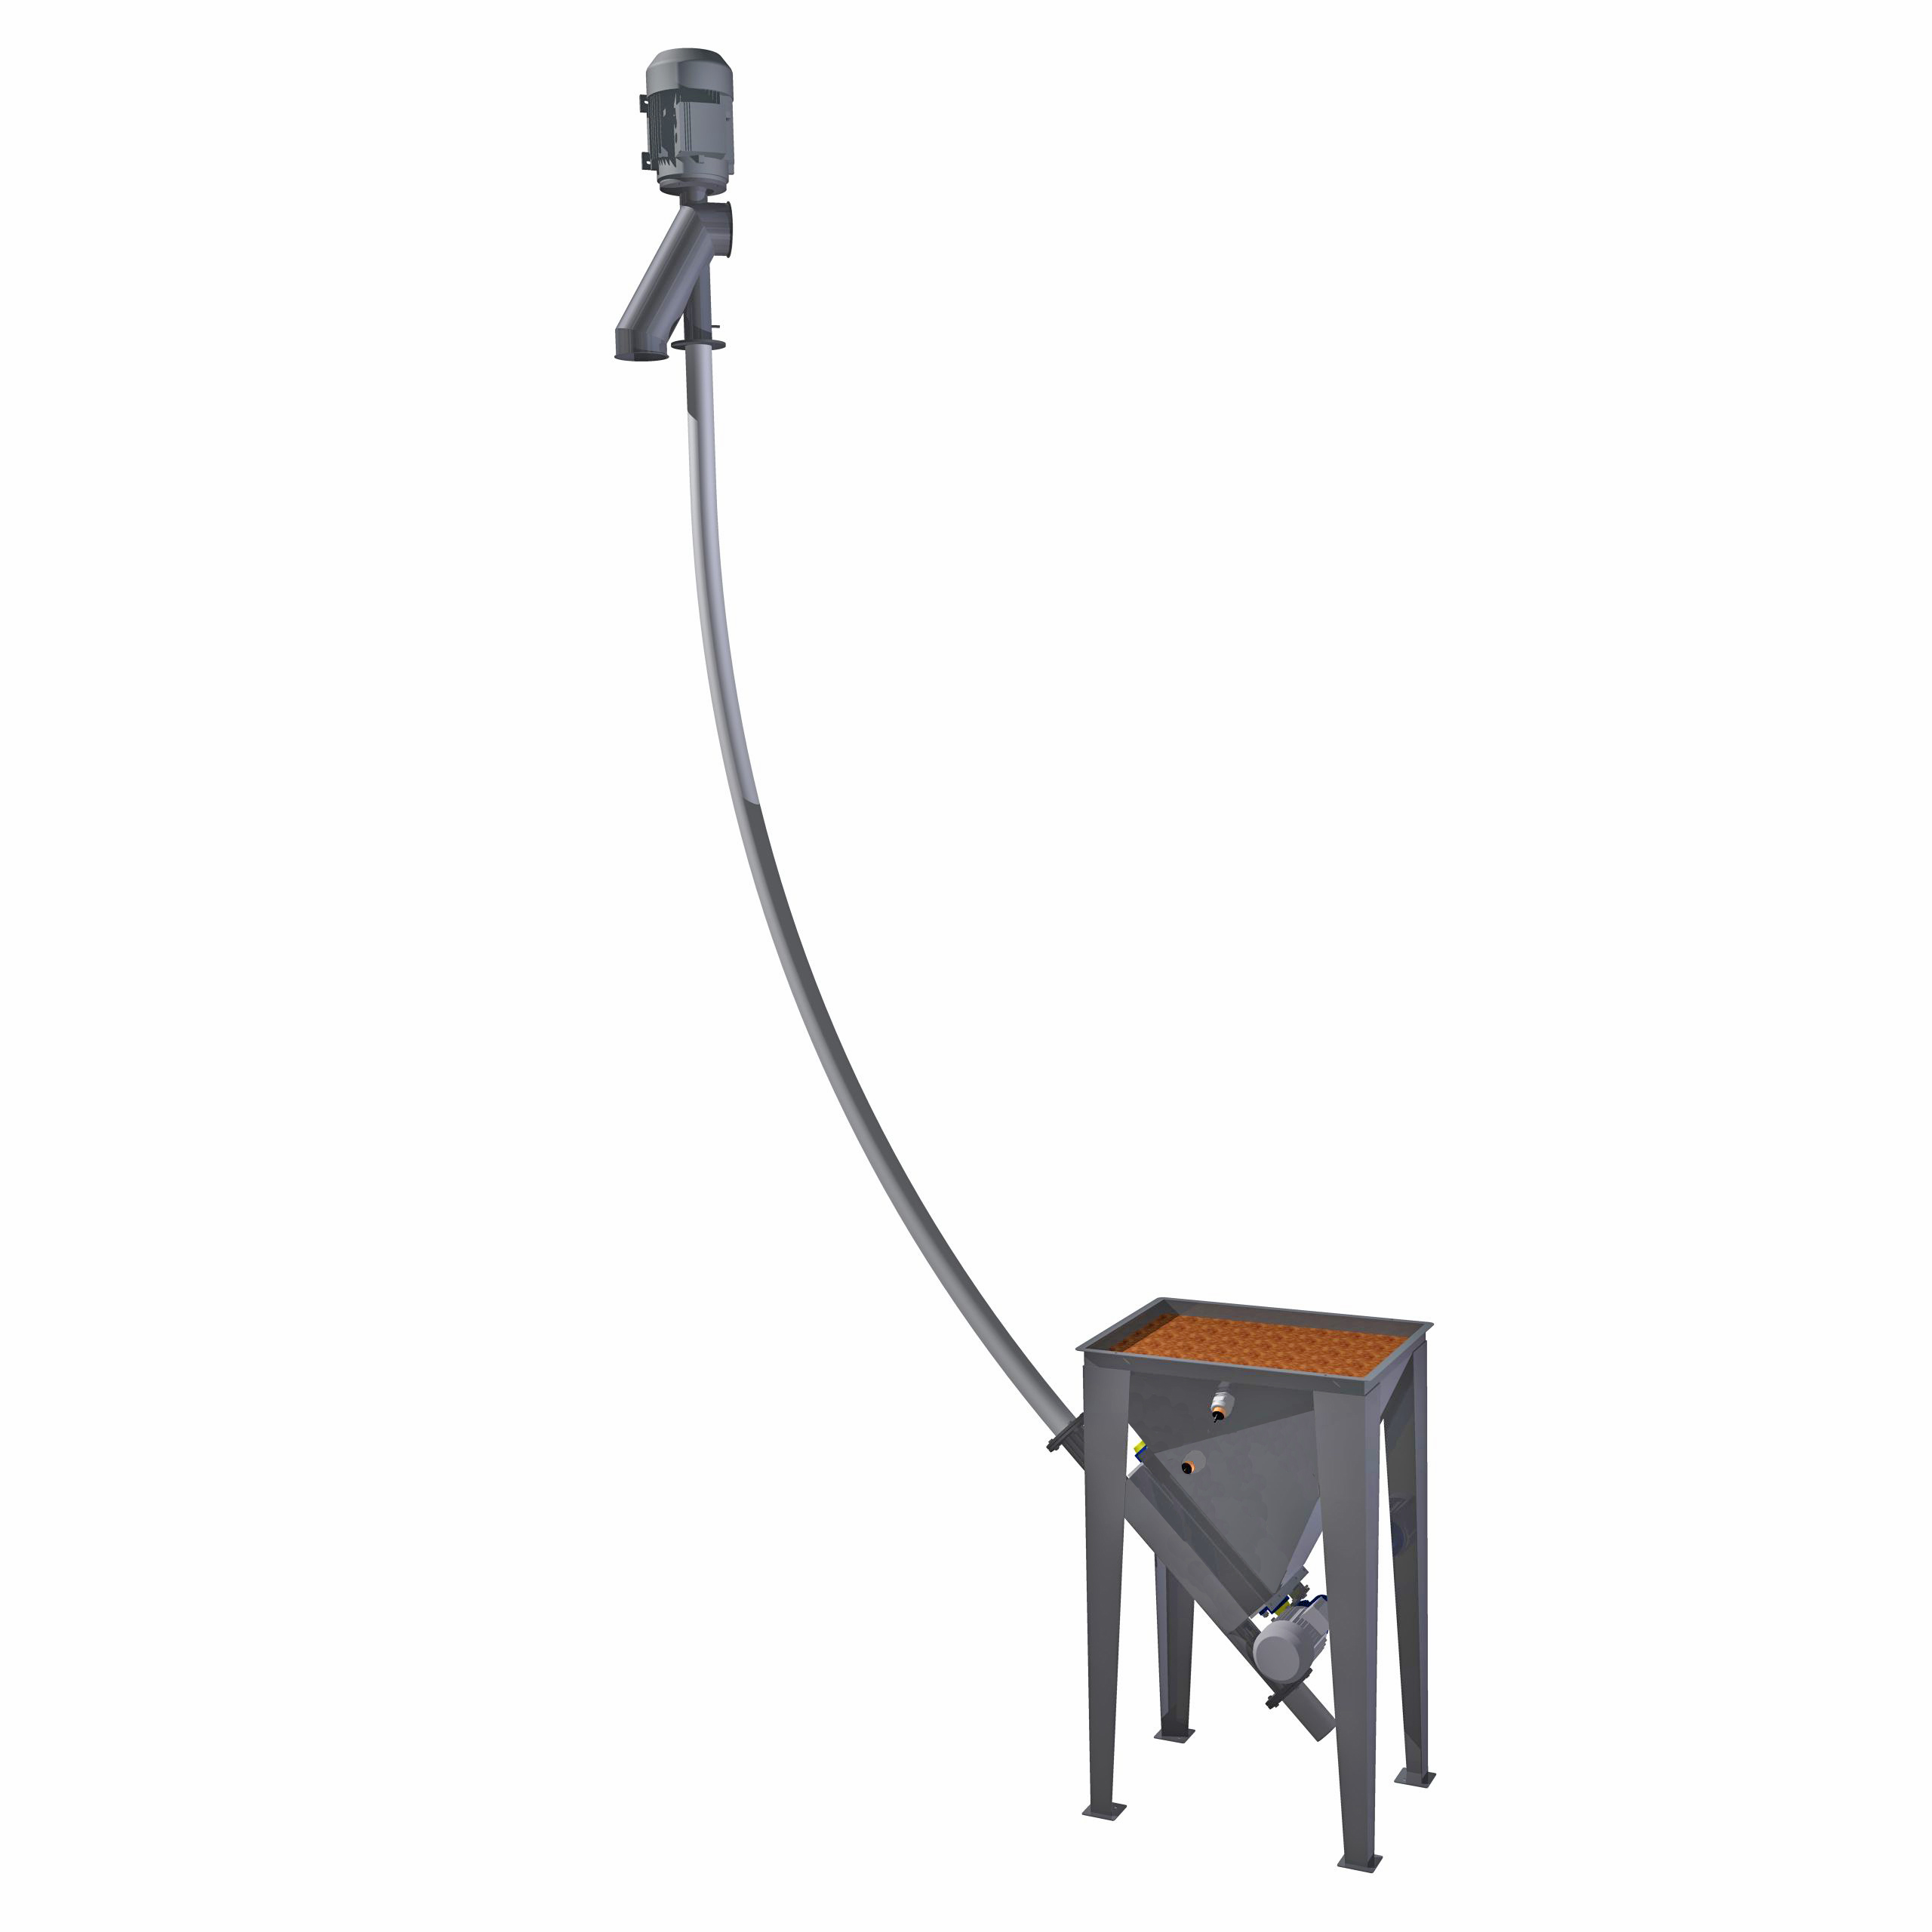

Caption #3
Optional quick-clean inlet to the new ‘Spiroflow’ Flexible Screw Conveyor is shown.

