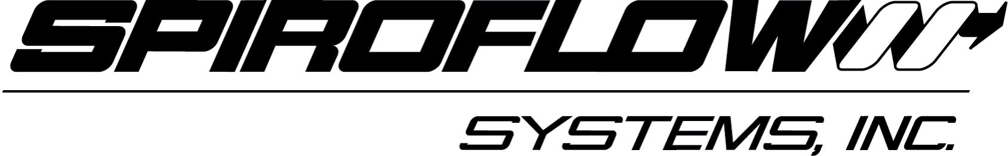 NEWS RELEASE

SPIROFLOW SYSTEMS, INC. INTRODUCES BULK BAG FILLER
WITH NEW ADVANCED CONTROL PACKAGE

Contact: Dick Stark FOR IMMEDIATE RELEASE

803-802-7141 x12
dick.stark@starklmc.com

CHARLOTTE, NORTH CAROLINA -- Spiroflow Systems, Inc. introduces the redesigned C1-2 Bulk Bag Filler complete with a new programmable controller designed to increase filling accuracy and cycle speed.

Filling Accuracy & Speed
The C1-2 Bulk Bag Filler uses an automatic gain in weight adjustment to monitor and compensate for any weight variation. Using programmable one-touch controls, the C1-2 Bulk Bag Filler operator can control Bulk Bag Filler operations as well as upstream in-feed devices. With accuracy within 1%, the C1-2 Bulk Bag Filler is ideal for companies who seek NTEP resale approval.

A filling rate of up to 20 bags an hour is attainable, depending on the ‘flowability’ of the product and the storage hopper or conveyor used to deliver the product to the C1-2 Bulk Bag Filler. The system offers broad applications in numerous industries including chemical, food, dairy, pharmaceutical, animal feed, plastics, minerals and aggregates.

Options
An additional benefit of the newly redesigned C1-2 Bulk Bag Filler is the greater ease to add custom features. The C1-2 Bulk Bag Filler can be customized to meet individual user requirements.

Below are some examples of custom features:

Power Height Adjustment: This option lets the operator quickly adjust the height between filling cycles to accommodate various sized Bulk Bags. ‘
(more)

NEW C1-2 SPIROFLOW BULK BAG FILLER
ADD 1

Retracting bag hooks: System that simultaneously opens/closes all bag hooks to allow for faster attachment/detachment of the Bulk Bag loops to the Bulk Bag Filler.
Filling nozzle and inflatable mechanical seal: A dust tight seal between the Bulk Bag Filler and the Bulk Bag for sanitary dust-free operation.
Liner inflation device: Inflates the Bulk Bag’s liner with ambient air and creates slight positive pressure to remove wrinkles and properly form the bag to assure maximum material capacity.
Roller Bed: The roller bed system ensures faster off-loading of filled bags for increased productivity.
Electric or pneumatic vibrators: During the filling process vibrators improve material densification and compaction of the material in the Bulk Bag for better storage and transport. This increases productivity and maximizes the use of space.

About Spiroflow Systems
Spiroflow is a worldwide supplier of a wide range of both standard and custom powder handling equipment, specializing in Bulk Bag Dischargers and Fillers, Mechanical, and Pneumatic Conveyors, a range of 50 lb Bag Packing and Unloading equipment and Flexible Storage Silos. The company offers a wide range of innovative designs and design options.

For more information about the C1-2 Bulk Bag Filler or Spiroflow’s complete line of powder handling equipment, visit www.spiroflowsystems.com, call 704-291-9595 or email info@spiroflowsystems.com.
###

Editor contact: Dick Stark or Kevin Nichols, Stark and Associates, Inc.
1171 Market St., Ste. 113, Fort Mill, SC 29708
PH: 803-802-7141 or email Dick.Stark@starklmc.com or Kevin.Nichols@Starklmc.com.

Caption

The redesigned C1-2 Bulk Bag Filler from Spiroflow Systems, Inc., features a new programmable
controller designed to increase filling accuracy and cycle speed. The C1-2 also uses an automatic gain in weight adjustment to monitor and compensate for any weight variation.
