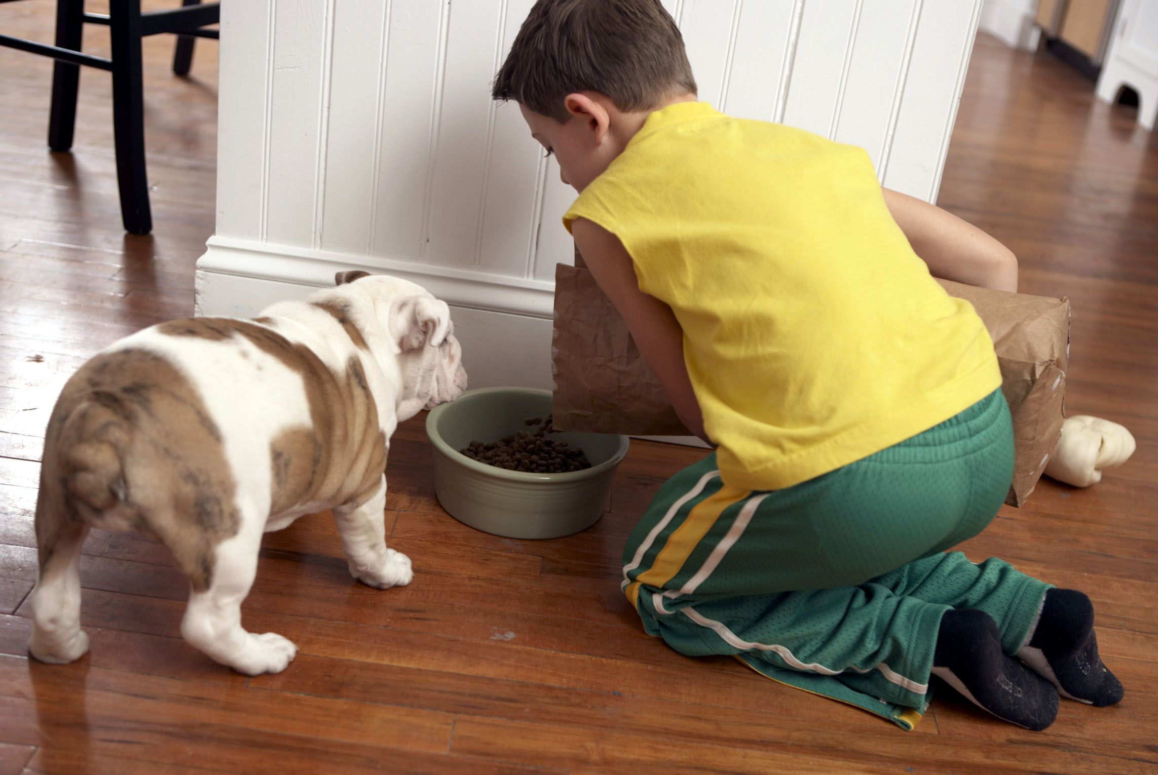
Editorial Contact:
Susan Russo
ABI
212-529-2635
srusso@abipr.com

ZIP-PAK SLIDER TECHNOLOGY IDEAL FOR LARGE FORMAT BAGS
Technology Provides Seal Integrity without Alteration to Pet Food Package Design
Las Vegas, NV – Zip-Pak, the global leader in resealable packaging innovations, introduces the ZIP-PAK® SLIDER™ for large format bags, the first slider zipper that adds convenience to large format bags, yet requires no alteration to the package design or construction.
The slider enables a resealable closure on laminate and multi-wall paper bags, which are popular choices for large format applications such as pet food, bulk wild bird seed and potting soil. ZIP-PAK® SLIDER™ for large format bags makes the addition of consumer-preferred resealable closures an option for a variety of package styles and applications.
The technology is available for packages up to 55 pounds, providing the same consumer experience and seal integrity for any pouch size throughout each use. Zip-Pak Systems, the company’s equipment division, provides unique consulting capabilities to ensure that packages pass all fitness for use tests.
Besides enhancing convenience, the new ZIP-PAK® SLIDER™ for large format bags eliminates the need for consumers to transfer package contents into separate storage containers to keep them fresh and well-contained. Brand owners benefit from packaging that stays in front of the consumer throughout use, maximizing marketing impact.
“ZIP-PAK® SLIDER™ family of technologies underscores Zip-Pak’s commitment to developing new innovations that help brand owners add value beyond the product itself,” said Elizabeth Sheaffer, Marketing Manager at Zip-Pak. “This technology was developed to help make strong brands even stronger.”
Ideal for pet, bird feed, and lawn and garden applications, the slider is ergonomically designed to easily glide the package open and closed for consumers of all ages.
# # #
About Zip-Pak
Zip-Pak, celebrating over 20 years of resealable packaging innovations, offers seven distinct technologies that provide the framework for more than 200 patented zipper profiles. A global leader for resealable packaging solutions, Zip-Pak is an Illinois Tool Works (ITW) Company. World headquarters are located in Manteno, IL, USA.
For further information on Zip-Pak, please see www.zippak.com or contact Elizabeth Sheaffer at + 1-815-468-6500 or elizabeth.sheaffer@zippak.com.
Editor's Note:
Images can be obtained by visiting www.abipressroom.com/zippak. If you have any questions or require additional information, please contact Susan Russo at srusso@abipr.com or +1 (212) 529-2635.

